**ServiceNow Ticket Assignment Automation**

**Project Report**: Streamlining Ticket Assignment for Efficient Support Operations

**Team ID: LTVIP2026TMIDS24973**

**Category:** ServiceNow

# Ideation Phase

The primary motivation behind this project is to eliminate inefficiencies in manual ticket routing processes at ABC Corporation. The manual method often leads to delayed resolutions, incorrect assignments, and underutilized support resources. The idea is to implement an automated, condition-based ticket assignment system using ServiceNow Flow Designer, minimizing delays and improving user satisfaction.

**2. Requirement Analysis:**

* Automate ticket routing in ServiceNow.

* Route based on issue type.

* Assign tickets to the right support group automatically.

Requirements:

* Create users and assign them roles.

* Create support groups.

* Define roles and ACL permissions.

* Design tables with specific columns and choice values.

* Implement logic-based flow automation.

* Maintain secure access and role-based data access.

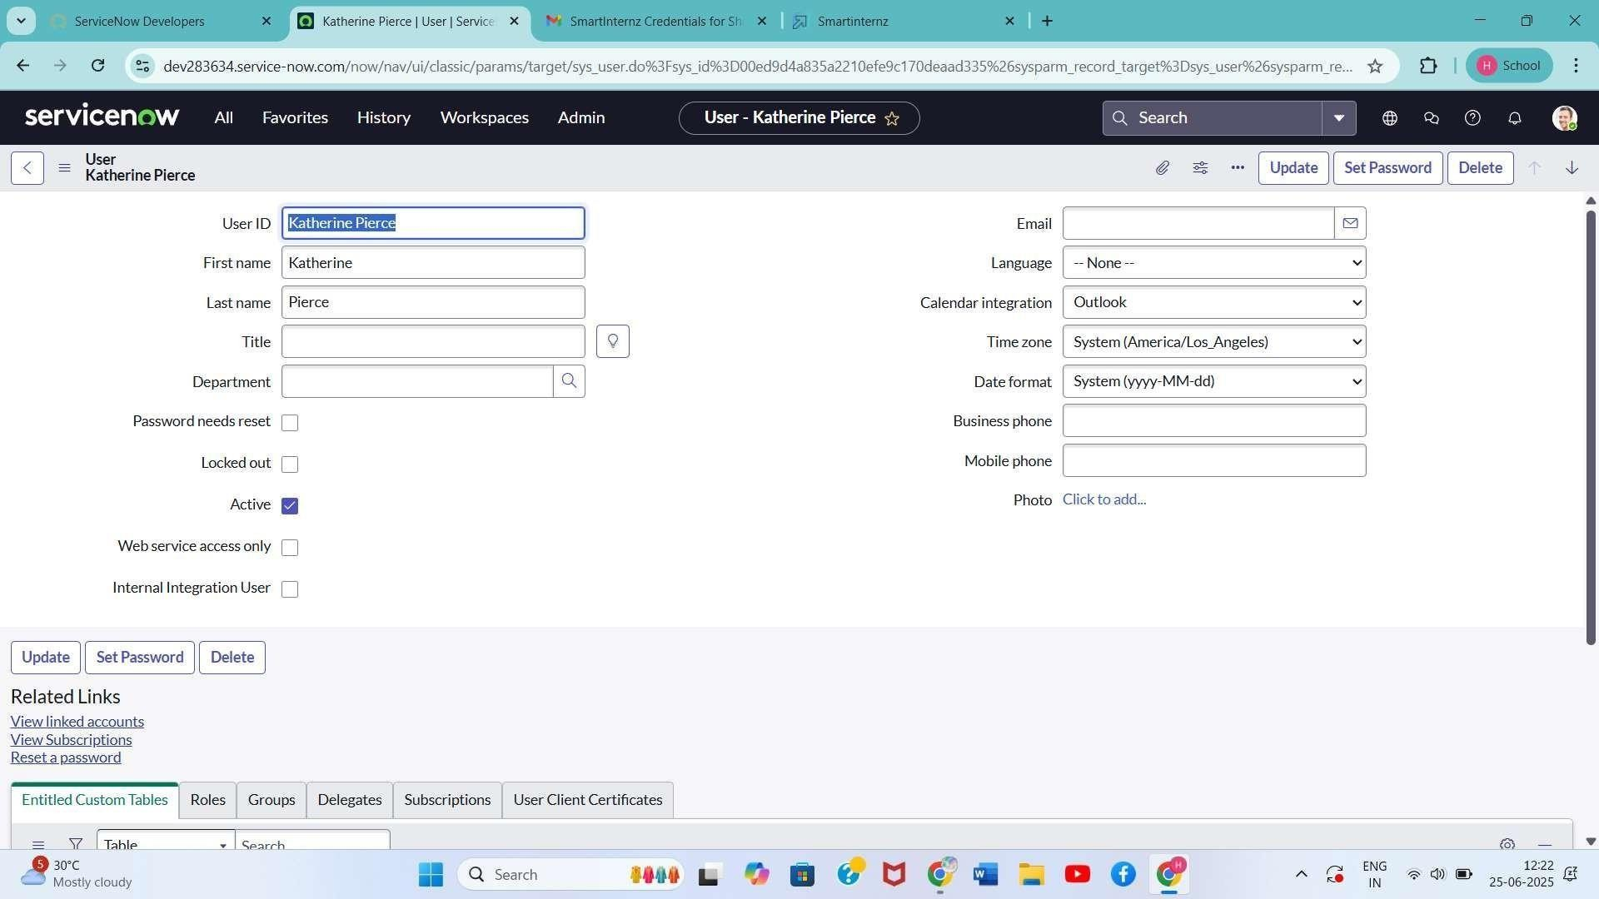

**3.**

**Project**

**planning**

**phase**

-

User

&

Role

Management

-

Group

Creation

-

Table

Creation

with

Column

Design

-

ACL

Setup

-

Flow

Designer

Automation

**Resources**

**Used:**

-

ServiceNow

Developer

Instance

-

Security

Admin

Role

-

System

User

**4.**

**Project**

**Design**

**phase:**

**User**

**Creation**

1.

Open

ServiceNow.

2.

Go

to

All

>

Users

(

System

Security)

3.

Click

New,

enter

required

details,

click

Submit.

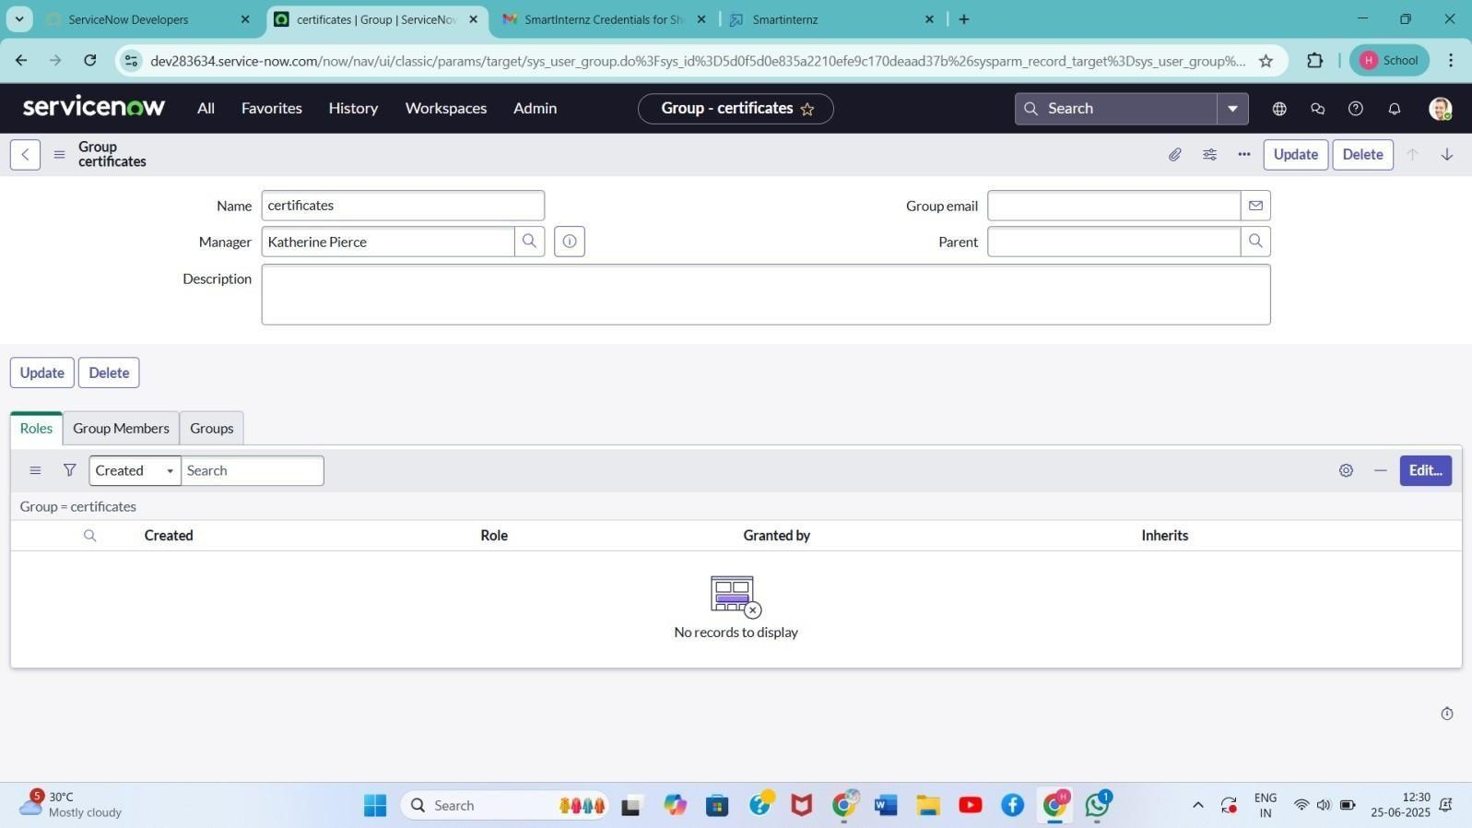

4.

Repeat

to

create

another

user.

**Group**

**Creation**

1.

Go

to

All

>

Groups

(

System

Security)

2.

Click

New,

fill

details

for

each

group

e.g.,

(

Certificates,

Platform),

click

Submit.

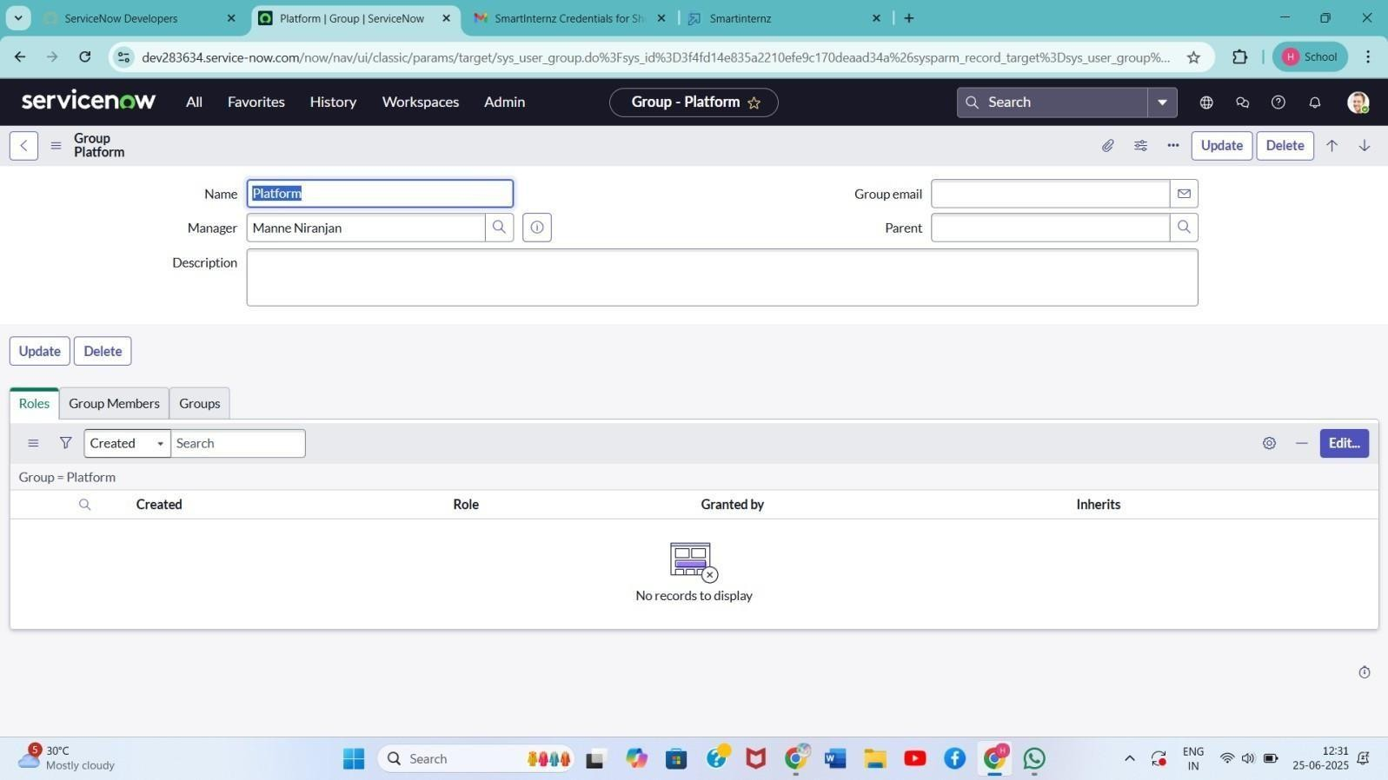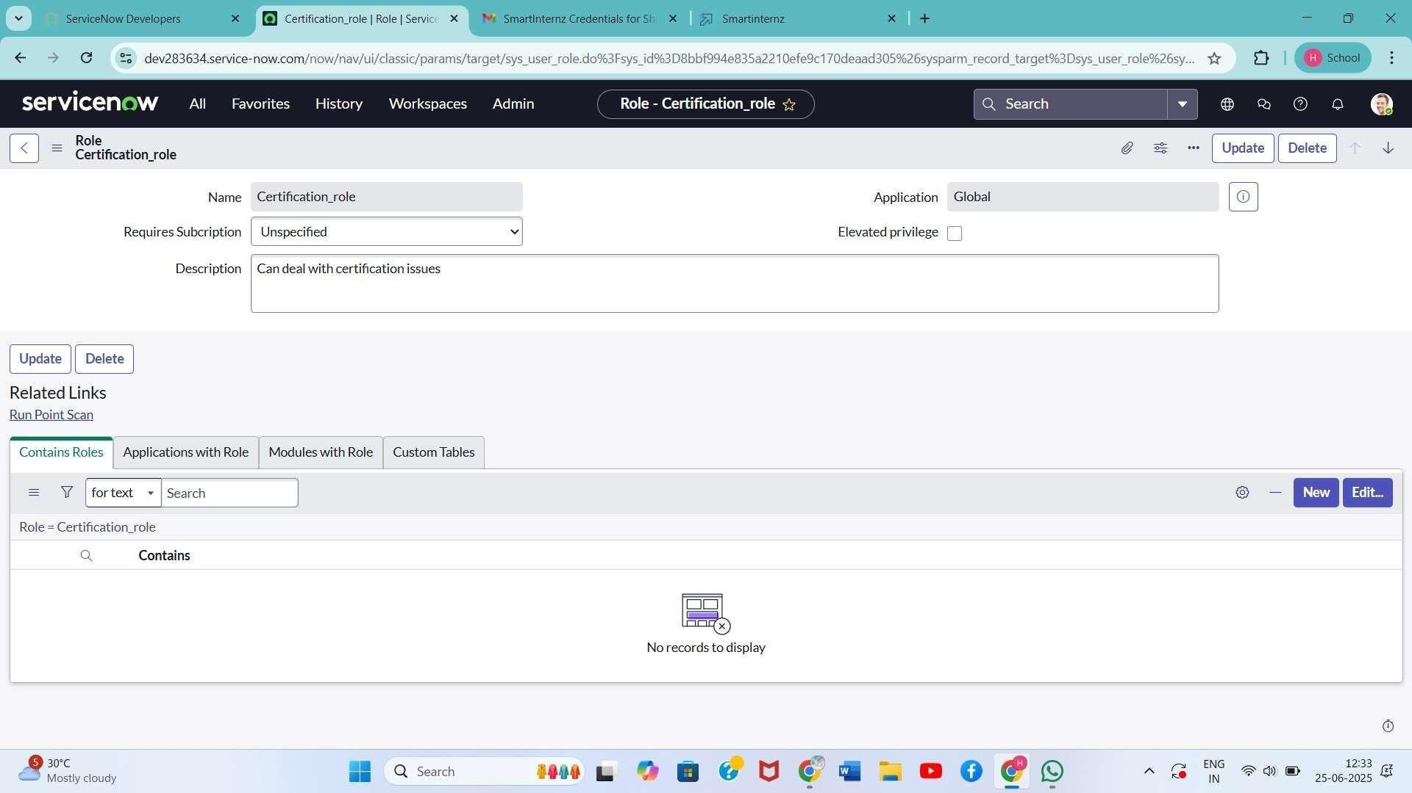

**Role**

**Creation**

1.

Go

to

All

>

Roles

System

(

Security)

2.

Click

New,

fill

details

for

Certification_role

and

Platform_role,

click

Submit.

# Table Creation

1. Go to All > Tables (System Definition)

1. Create a new table:

* + Label: Operations related

* + Check: Create module & Create mobile module

* + Menu Name: Operations related

* + Add Columns:

* + issue (Choice field)

* + assigned to group

* + other required fields

1. Use Form Designer to add choices to the issue field:

* + unable to login to platform

* + 404 error

* + regarding certificates

* + regarding user expired

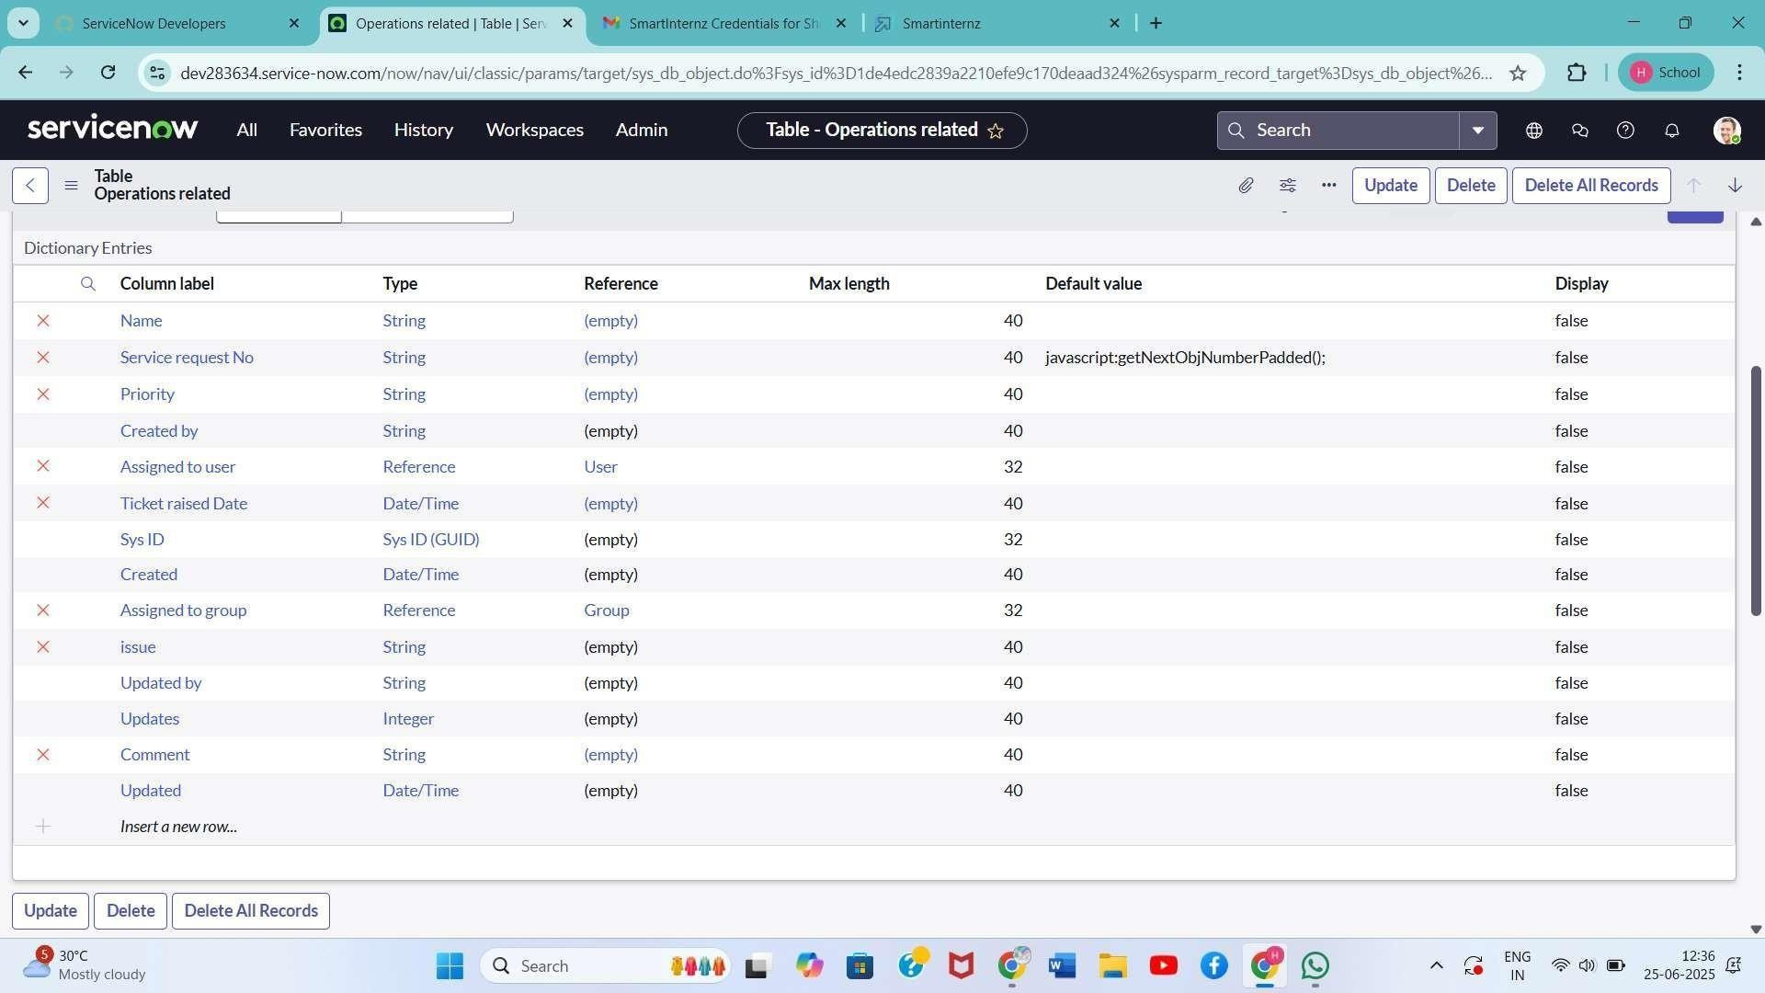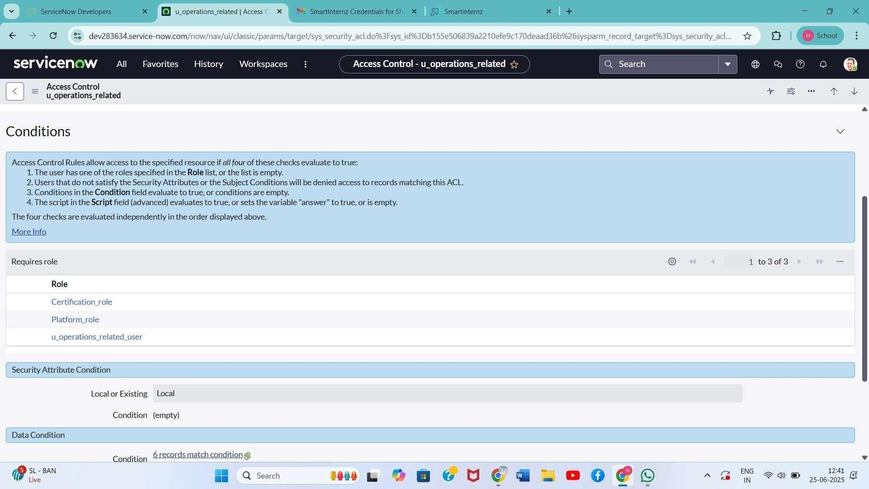

Assign

Users

to

Groups

-

Add

Katherine

Pierce

to

Certificates

group

with

Certification_role

-

Add

Manne

Nirajanan

to

Platform

group

with

Platform_role

**Access**

**Control**

**ACL**

**(**

**)**

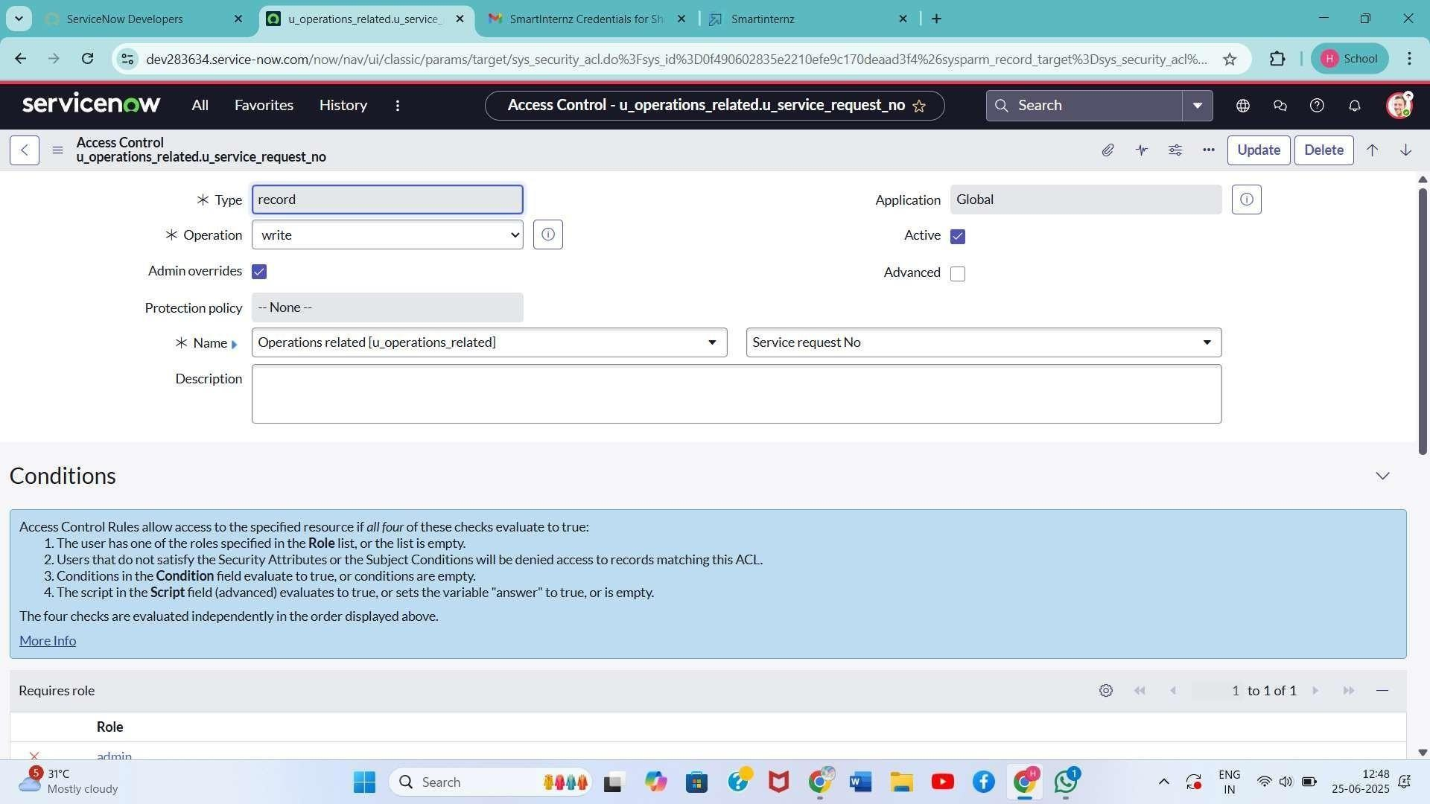

1.

Go

to

All

>

Access

Control

(

ACL

)

2.

Create

ACLs

for

table

Operations

related:

-

Read:

Requires

admin,

Platform_role,

and

Certificate_role

-

Write:

Requires

Platform_role

and

Certificate_role

-

Application

Access:

Enable

read/write

access

accordingly

3.

Elevate

role

using

Security

Admin

if

needed

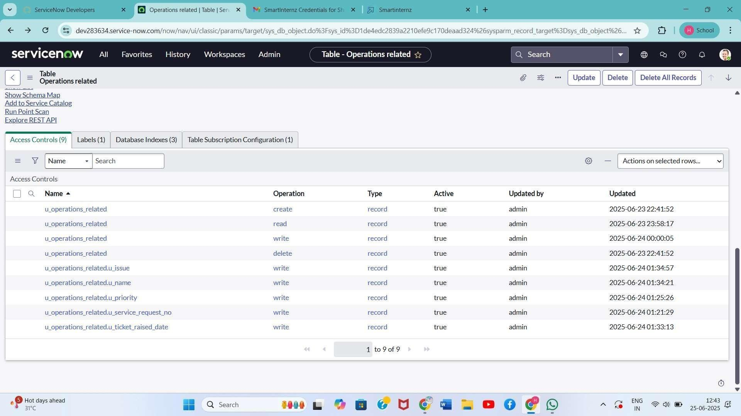

Flow

Designer

Regarding

Certificate

1.

Go

to

All

>

Flow

Designer

>

New

Flow

2.

Name:

Regarding

Certificate

3.

Application:

Global,

Run

user:

System

user

4.

Trigger:

-

Table:

Operations

related

-

Condition:

issue

is

regarding

certificates

5.

Action:

-

Update

Record:

Assigned

to

group

=

Certificates

6.

Click

Save

and

Activate

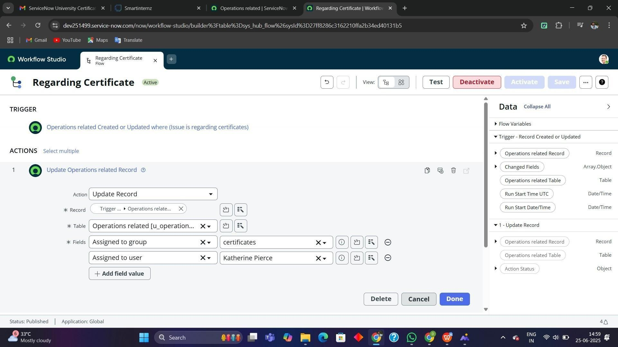

Flow

Designer

Regarding

Platform

1.

Create

New

Flow:

Regarding

Platform

2.

Trigger:

-

Table:

Operations

related

-

Conditions:

-

issue

is

Unable

to

login

to

platform

-

issue

is

404

Error

-

issue

is

Regarding

user

expired

3.

Action:

-

Update

Record:

Assigned

to

group

=

Platform

4.

Click

Save

and

Activate

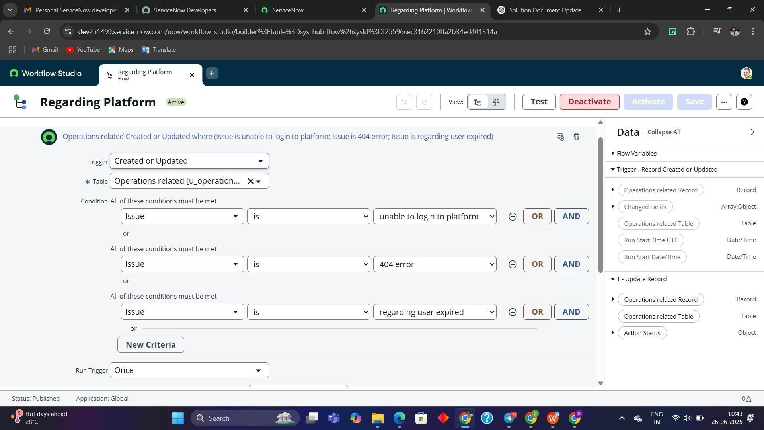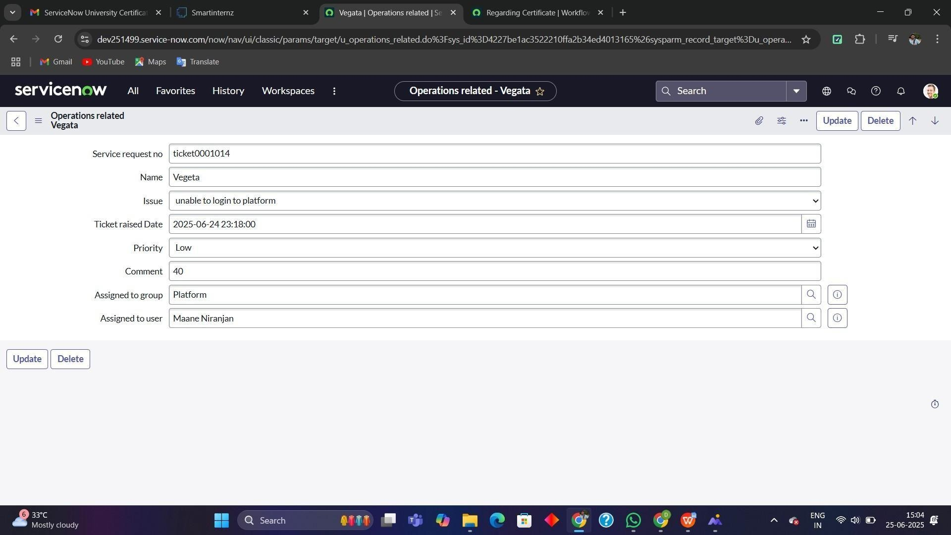

**5.**

**Performance**

**Testing:**

Test

Scenarios:

-

Create

a

record

in

Operations

related

with

each

issue

type

-

Verify

assignment

is

correct

based

on

issue

-

Validate

ACL

enforcement

by

accessing

table

data

with

users

in

different

roles

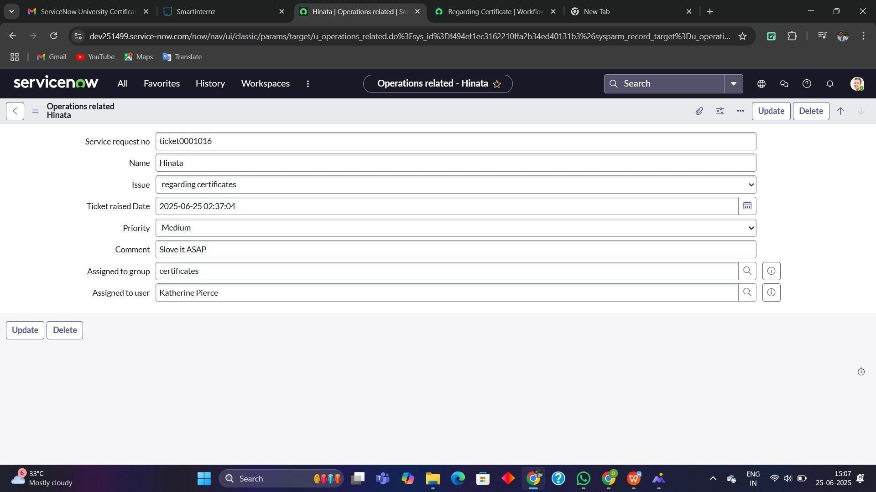

**Results:**

-

All

tickets

assigned

correctly

based

on

issue

-

Unauthorized

users

restricted

from

modifying

sensitive

data

-

Groups

receive

only

relevant

tickets

**Conclusion:**

This automation significantly improves the efficiency of ticket handling in ServiceNow. It ensures

timely resolution by directing the tickets to appropriate groups based on predefined criteria. The

use

of

Flow

Designer and

ACLs offers a

secure

and

scalable

foundation

for managing

enterprise

-

level support systems.